CS-235

Computer Organization and Assembly Language

Lab Assignment 02

Name: Mahum Samar

Class: BSCS-9B

CMS ID: 290647

## Submitted to : Ma’am Qurat-ul-Ain

# Question # 01

## Output:

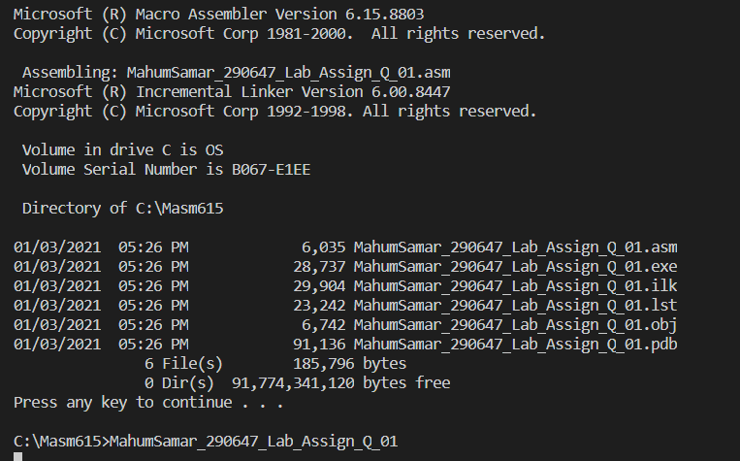

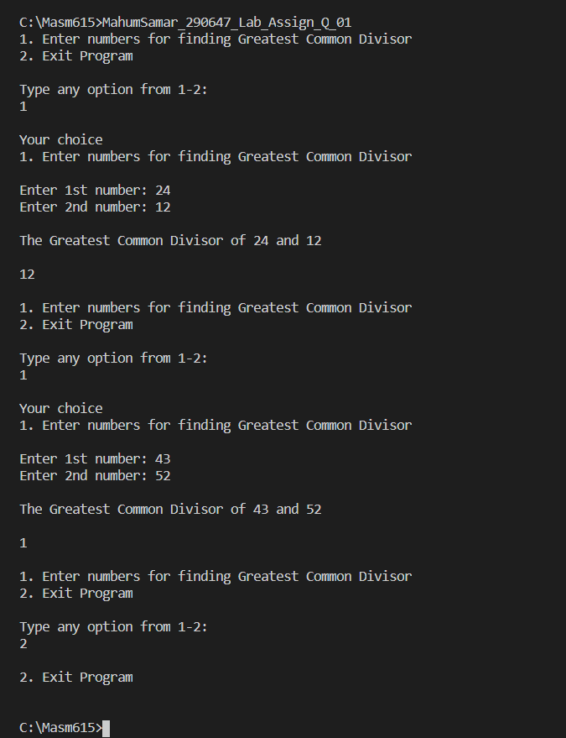

# Question # 02

## Output:

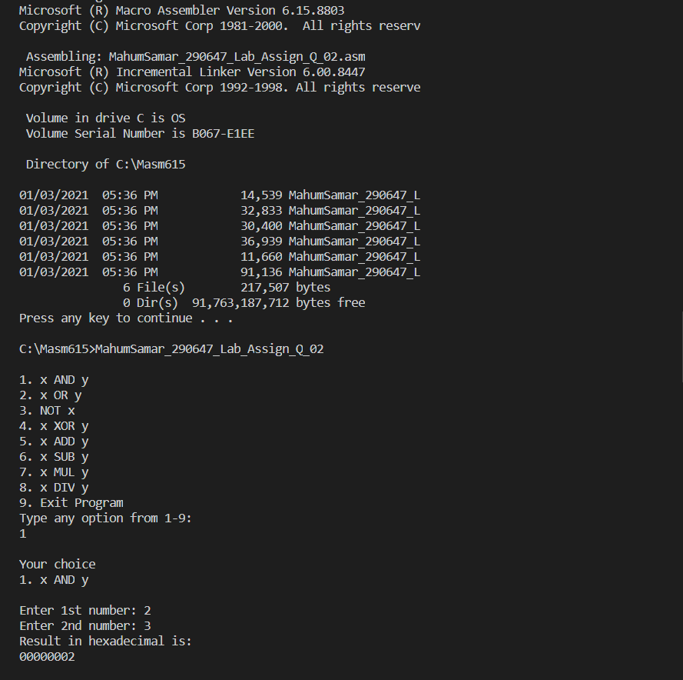

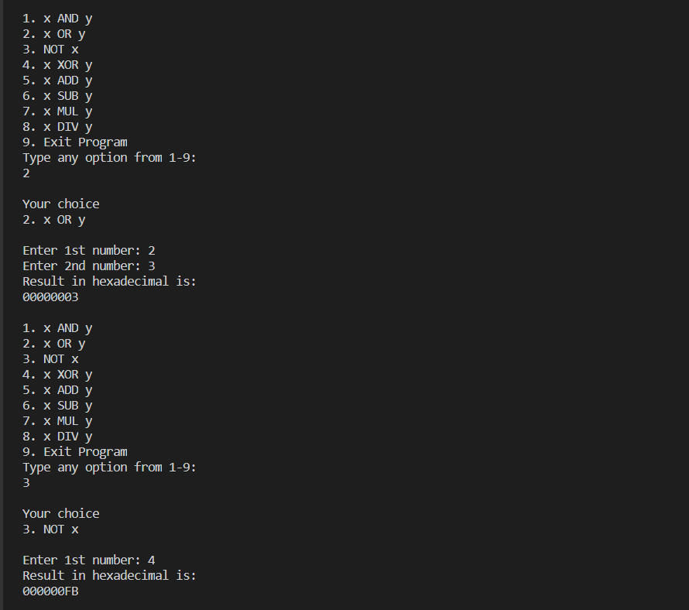

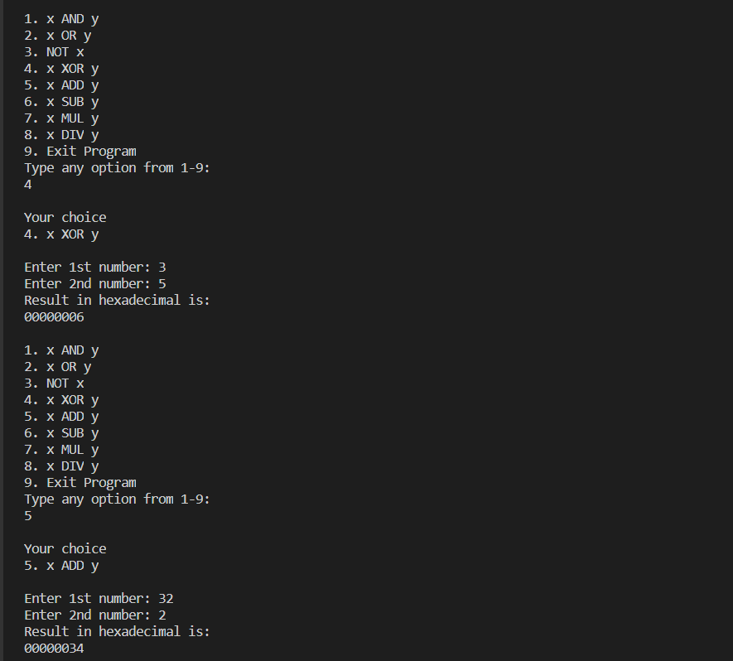

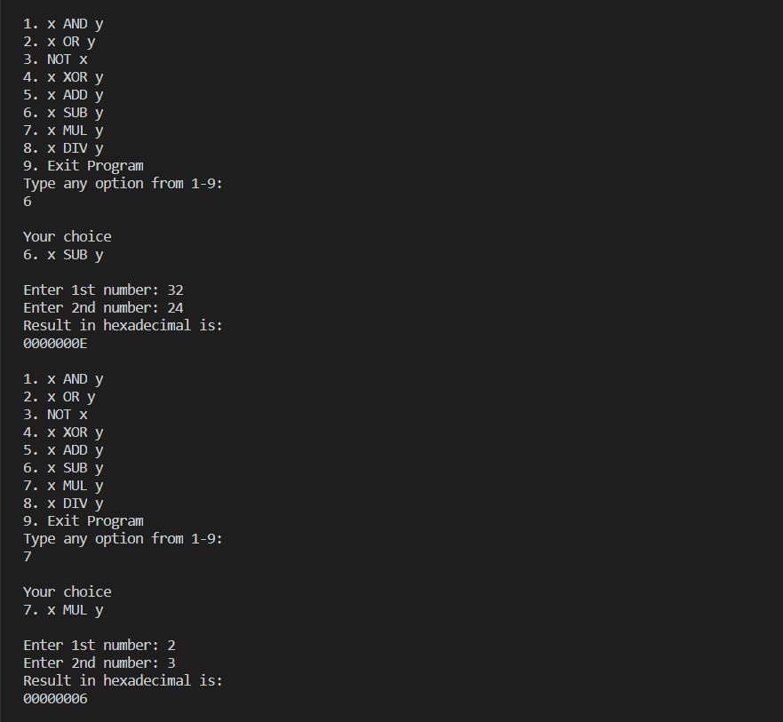

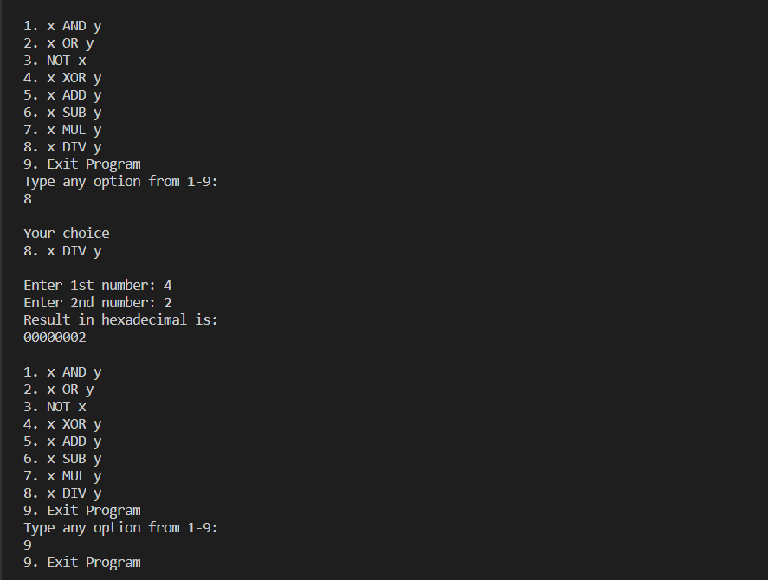

# Question # 03

## Part (a)

### When does divide overflow occur? What is its effect on result. Give an example of divide overflow. 2.5 marks

|  |
| --- |
| Division overflow occurs when the DIV operation produces the quotient which is larger than the destination operand. This will halts the current program. Example: Mov ax, 2000h  Mov bl,10h  Div bl  The above example produces quotient i.e. 200h which cannot be placed in 8-bit Al register. So, division overflow occurs. |

## Part (b)

### How can we use instruction IMUL. How it differs from MUL. Give an example. 2.5 marks

|  |
| --- |
| * IMUL command is used to perform the signed multiplication on integers. * IMUL instruction preserves the sign of the product while MUL instruction does not preserve the sign of product. * IMUL have 3 formats having one operand, two operands and three operands.  Example:  * IMUL al   This instruction stores result in ax by multiplying al with al   * IMUL eax, value, 5   Stores result in eax by multiplying “value” and “4”. |